MAY 2020 – Version R00

Section X :

Technical Clauses for Electrical Leak Location Methods on Geomembrane Materials

Table of Contents
1. General Conditions 1
1.1 Contents 1
1.2 Roles and Responsibilities 1
A. Project Owner 1
B. Engineer 1
C. General Contractor 1
D. Installer 1
E. Quality Assurance Representative 2
F. Manufacturer 2
1.3 References 2
2. Required Experience of the Electrical Leak Location Operator 2
3. Implementation 3
3.1 Electrical Leak Location Methods for Exposed Geomembranes 3
A. Spark Test Method 3
A.1 Method Description 3
A.2 Information to be Provided by the Engineer or Contractor 4
A.3 Method Specific Requirements 4
A.4 Methodology 4
A.5 Final Report 5
B. Arc Test Method 5
B.1 Method Description 5
B.2 Information to be Provided by the Engineer or Contractor 6
B.3 Method Specific Requirements 6
B.4 Methodology 6
B.5 Final Report 6
C. Water Puddle Method 6
C.1 Method Description 6
C.2 Information to be Provided by the Engineer or Contractor 7
C.3 Method Specific Requirements 7
C.4 Methodology 8
C.5 Final Report 8
3.2 Electrical Leak Location Methods for Covered Geomembranes 8
A. Dipole Method 8
A.1 Method Description 8
A.2 Information to be Provided by the Engineer or Contractor 9
A.3 Method Specific Requirements 9
A.4 Methodology 10
A.5 Final Report 10

General Conditions

Contents
This document presents technical clauses for the qualification of the electrical leak location operator (the “Operator”) as well as requirements for each of the electrical leak location methods on exposed and covered geomembranes.
Section 3.1 : Electrical Leak Location Methods for Exposed Geomembranes
These methods allow for the detection of faults caused during geomembrane installation.
Section 3.2 : Electrical Leak Location Methods for Covered Geomembranes.
These methods allow for the detection of faults caused during the installation of covering materials.

Roles and Responsibilities

Project Owner
The individual or legal entity for whom the project works are to be completed.

Engineer
The Engineer is responsible for the design of the project using geosynthetic materials and for the preparation of project plans and specifications. The Engineer is mandated by the Project Owner to monitor the execution of project construction works and to coordinate their reception and payment.

General Contractor
The company, and representatives thereof, contractually mandated by the Project Owner to perform project construction works. The General Contractor is normally responsible for the preparation of the base layer onto which geosynthetic materials are installed as well as the installation of covering materials for drainage and protection.

Installer
The company, and representatives thereof, contracted by the Project Owner or the General Contractor to complete works related to the installation of geosynthetic materials.

Quality Assurance Representative
Company responsible for works surveillance and the quality assurance of geosynthetic materials. The Quality Assurance Representative can be the Project Owner, the Entrepreneur, or an external company. The Quality Assurance Representative should be independent of the Installer and the Installer’s subcontractors and manufacturers.

Manufacturer
The Manufacturer is responsible for the factory production of geosynthetic materials.

References
Electrical leak location methods should be performed in conformity with the standard practices described by the American Society for Testing and Materials (ASTM).
- General:
  - ASTM D6747: Standard Guide for Selection of Techniques for Electrical Detection of Potential Leak Paths in Geomembranes.
- Exposed Geomembrane:
  - ASTM D7002: Standard Practice for Leak Location on Exposed Geomembranes Using the Water Puddle System
  - ASTM D7953: Standard Practice for Electrical Leak Location on Exposed Geomembranes Using the Arc Testing Method
  - ASTM D7240: Leak Location using Geomembranes with an Insulating Layer in Intimate Contact with a Conductive Layer via Electrical Capacitance Technique (Conductive Geomembrane Spark Test)
- Covered Geomembrane:
  - ASTM D7007: Electrical Methods for Locating Leaks in Geomembranes covered with Water or Earthen Materials
  - ASTM D8265: Standard Practices for Mapping Leaks in Installed Geomembranes.

Required Experience of the Electrical Leak Location Operator
The electrical leak location Operator is a company independent of the Owner, the General Contractor and Installer.
For exposed geomembrane surveys (spark test, art test and water puddle methods), the electrical leak location Operator should have surveyed a minimum of 250,000 m² of geosynthetic materials in the last 5 years across at least 20 different projects.
For covered geomembrane surveys (dipole method), the electrical leak location Operator should have surveyed a minimum of 500,000 m² of geosynthetic materials in the last 5 years across at least 30 different projects.
Groupe Alphard is an electrical leak location Operator that posses the required level of experience for both covered and exposed geomembrane surveys (www.leaklocationalphard.com or www.alphard.com).

Implementation
The following sub-sections present the different electrical leak location methods on exposed and covered geomembranes as well as their respective requirements and methodologies.
[Only sections relevant to the selected methods should be included]

Electrical Leak Location Methods for Exposed Geomembranes
The method to be used in this project is the _____________________ method. [Enter “spark test”, “arc test”, or “water puddle”]
[Include section A, B or C]

Spark Test Method

Method Description
The spark test method of electrical leak location (ASTM standard D7240, “Standard Practice for Leak Location Using Geomembranes with an Insulating Layer in Intimate Contact with a Conductive Layer via Electrical Capacitance Technique [Conductive Geomembrane Spark Test]”) allows for the detection of faults caused during the installation of a conductive geomembrane.
The coextruded manufacturing of geomembrane materials produces geomembranes with an isolating core and a conductive layer. This configuration allows for the use of the spark test electrical leak location method.
To perform a spark test survey, the geomembrane material must be installed with the conductive layer face down. A portable electrical source is used to charge the geomembrane material with a conductive element, commonly a conductive neoprene disc. The electrical charge passed into the geomembrane material by capacitance (magnetic field), and when the metal wand passes close to fault this charge is released as a spark between the wand and the conductive layer. The resulting signal is detected by the wand and an alarm is sounded to notify the Operator of the leak.
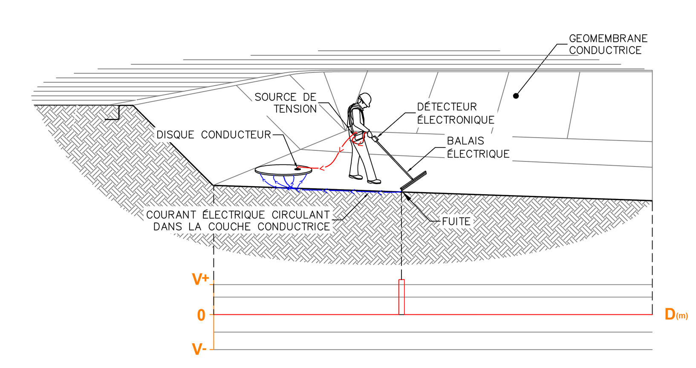

Information to be Provided by the Engineer or Contractor
- Details of all layers comprising the impermeability system.
- Details of all structures penetrating the geomembrane layer.
- Descriptions of all structures above the geomembrane layer.
- Estimated date and location of the electrical leak location survey.
- Site plans and/or photocopies, where possible.

Method Specific Requirements
- The method must not be performed in rainy conditions. Light drizzle is acceptable, but the method must not be performed in consistent rain.
- The geombrane layer must be free of gravel, debris and puddles.
- The geomembrane layer must be installed with the conductive layer face down.
- All overlaps in the geomembrane material should be ground down above the embankment to prevent an electrical connection to the site’s exterior in the anchoring section.

Methodology
- The Operator must inspect the survey site prior to the beginning of the survey in order to confirm that site conditions are suitable for the selected method.
- Any discrepancy with the method specific requirements should be reported to the Contractor for correction.
- The Operator must perform the survey in conformity with the procedures outlined in the most recent version of the relevant ASMT standard.
- The Operator must inform onsite representatives (using paint, marker flags or geographic coordinates) of the location of faults discovered during the survey.
- Following fault repair, all repairs should be reinspected using the selected method in order to ensure their integrity.

Final Report
The Operator must provide a survey report in conformity with the minimum requirements of the relevant ASTM standard within 2 weeks of completion of the survey.

Arc Test Method

Method Description
The arc test method of electrical leak location (ASTM standard D7953, “Standard Practice for Electrical Leak Location on Exposed Geomembranes Using the Arc Testing Method”) allows for the detection of faults caused during the installation of a geomembrane.
A high electrical voltage (around 30,000 V) is applied to a metal wand and a grounding electrode is installed outside of the survey area. No water sources is required for the application of this method, as the contact between the wand and the ground is made through an electrical arc. In the presence of a fault the electrical circuit begins at the wand, passes as an electrical arc into the site’s base layer beneath the geomembrane, and reaches the grounding electrode. An alarm is then sounded notifying the Operator of the fault. This method allows for the validation of the entirety of the geomembrane surface.
.
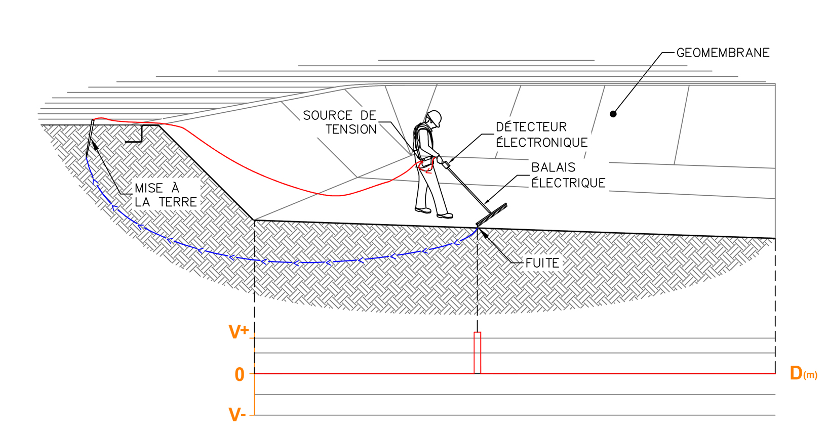

Information to be Provided by the Engineer or Contractor
- Details of all layers comprising the impermeability system.
- Details of all structures penetrating the geomembrane layer.
- Descriptions of all structures above the geomembrane layer.
- Estimated date and location of the electrical leak location survey.
- Site plans and/or photocopies, where possible.

Method Specific Requirements
- The site’s base layer must not be frozen. The method must not be performed in rainy conditions. Light drizzle is acceptable, but the method must not be performed in consistent rain.
- The geombrane layer must be free of gravel, debris and puddles.

Methodology
- The Operator must inspect the survey site prior to the beginning of the survey in order to confirm that site conditions are suitable for the selected method.
- Any discrepancy with the method specific requirements should be reported to the Contractor for correction.
- The Operator must perform the survey in conformity with the procedures outlined in the most recent version of the relevant ASMT standard.
- The Operator must inform onsite representatives (using paint, marker flags or geographic coordinates) of the location of faults discovered during the survey.
- Following fault repair, all repairs should be reinspected using the selected method in order to ensure their integrity.

Final Report
The Operator must provide a survey report in conformity with the minimum requirements of the relevant ASTM standard within 2 weeks of completion of the survey.

Water Puddle Method

Method Description
The water puddle method of electrical leak location (ASTM standard D7002 “Standard Practice for Leak Location on Exposed Geomembranes Using Water Puddle System”) allows for the detection of faults caused during the installation of a geomembrane.
The water puddle method uses the insulating properties of the geomembrane surface to locate faults (see figure below). Continuous current is applied to the metal wand and a grounding electrode is installed outside of the survey area. In the presence of a leak large enough for water to pass through, an electrical circuit is created between the wand, the water passing through the leak, the site base layer and the grounding electrode. An alarm is then sounded to notify the Operator of the leak. As the wand distributes water over the entirety of the geomembrane surface, the entirety of the surface can be validated during the survey. The water puddle method is able to detect faults with a diameter of less than 1mm².
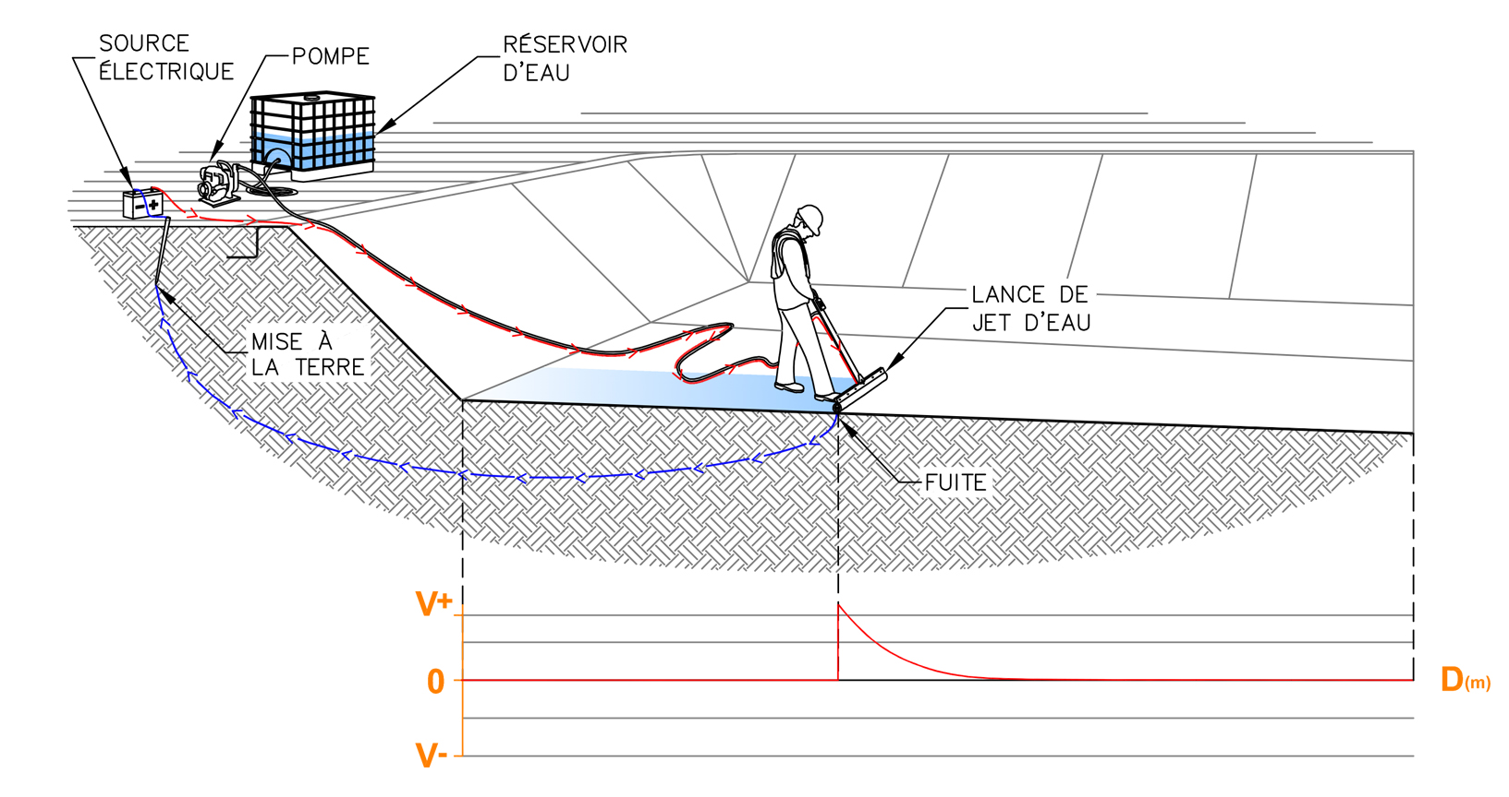

Information to be Provided by the Engineer or Contractor
- Details of all layers comprising the impermeability system.
- Details of all structures penetrating the geomembrane layer.
- Descriptions of all structures above the geomembrane layer.
- Estimated date and location of the electrical leak location survey.
- Site plans and/or photocopies, where possible.

Method Specific Requirements
- The site’s base layer must not be frozen. The method must not be performed in rainy conditions. Light drizzle is acceptable, but the method must not be performed in consistent rain.
- The Site Owner or Contractor must ensure an adequate water supply (around 5 m³ per day delivered by cistern and pump) is available on site.
- The geombrane layer must be free of gravel, debris and puddles.
- It is strongly recommended that water puddle surveys begin at a low point of the survey site in order to avoid water accumulating in low areas before they are validated.

Methodology
- The Operator must inspect the survey site prior to the beginning of the survey in order to confirm that site conditions are suitable for the selected method.
- Any discrepancy with the method specific requirements should be reported to the Contractor for correction.
- The Operator must perform the survey in conformity with the procedures outlined in the most recent version of the relevant ASMT standard.
- The Operator must inform onsite representatives (using paint, marker flags or geographic coordinates) of the location of faults discovered during the survey.
- Following fault repair, all repairs should be reinspected using the selected method in order to ensure their integrity.

Final Report
The Operator must provide a survey report in conformity with the minimum requirements of the relevant ASTM standard within 2 weeks of completion of the survey.

Electrical Leak Location Methods for Covered Geomembranes
The method selected for this project is the _____________________ [enter “dipole”].
[Include section A]

Dipole Method

Method Description
The dipole method of electrical leak location (ASTM standard D7007(“Standard Practices for Electrical Methods for Locating Leaks in Geomembranes Covered with Water or Earth Materials”) allows for the detection of faults caused during the installation of covering material layers.
The dipole method uses the insulating properties of the geomembrane surface to locate faults (see figure below). A continuous current of around 550 V is applied directly to the covering material and a grounding electrode is installed outside of the survey area. This allows electrical current to pass through any faults in the geomembrane material, generating an electrical field that can be detected by a qualified technician.
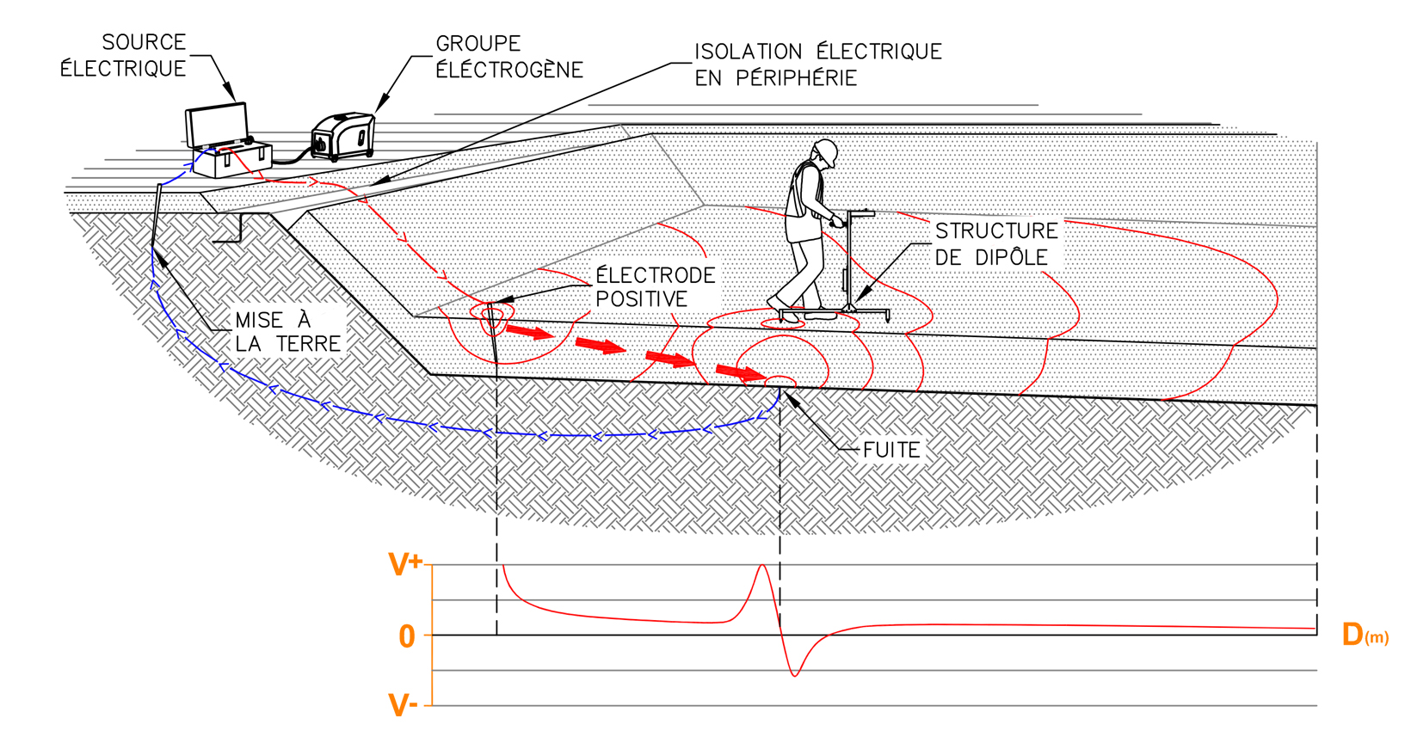

Information to be Provided by the Engineer or Contractor
- Details of all layers comprising the impermeability system.
- Details of all structures penetrating the geomembrane layer.
- Descriptions of all structures above the geomembrane layer.
- Estimated date and location of the electrical leak location survey.
- Site plans and/or photocopies, where possible.

Method Specific Requirements
- The site’s base layer must not be frozen. The method must not be performed in rainy conditions. Light drizzle is acceptable, but the method must not be performed in consistent rain.
- The covering material should be humid enough to provide good electrical contact between the leak location equipment and the soil layer.
- The covering material must not be frozen and must be less than one (1) metre thick. A covering material layer comprised of sub-layers of different materials may reduce the effectiveness of the survey.
- The covering material layer should be electrically isolated from soil at the exterior of the site along the entirety of its perimeter (see figure below)
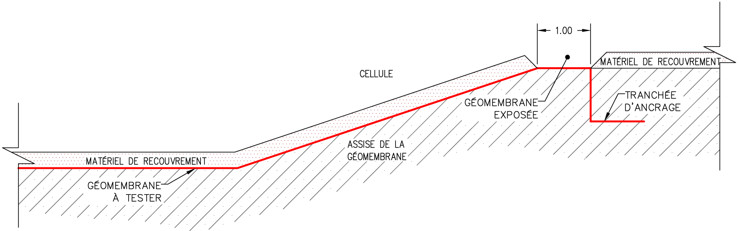
- The base layer on which the geomembrane material is installed must be electrically conductive.
- The Owner or the General Contractor is responsible for the removal and reinstallation of the covering layer material when a fault is detected by the Operator.
- The Owner or the General Contractor must provide a generator (110 V AC) to power the dipole method equipment. The Owner or the General contractor is responsible for the maintenance and operation of the generator.

Methodology
- The Operator must inspect the survey site prior to the beginning of the survey in order to confirm that site conditions are suitable for the selected method.
- Any discrepancy with the method specific requirements should be reported to the Contractor for correction.
- The Operator must perform the survey in conformity with the procedures outlined in the most recent version of the relevant ASMT standard.
- A leak simulation is required to validate the quality of the signal in actual project conditions and to confirm the applicability of the method (the simulated leak should be 6mm in dimeter).
- The Operator must inform onsite representatives (using paint, marker flags or geographic coordinates) of the location of faults discovered during the survey.

Final Report
The Operator must provide a survey report in conformity with the minimum requirements of the relevant ASTM standard within 2 weeks of completion of the survey.

